ANNA UNIVERSITY, CHENNAI 25

MODEL QUESTION PAPER

B.E. Aeronautical Engineering, VI SEMESTER

AE343 COMPOSITE MATERIAL AND STRUCTURES

TIME – 3 Hours MAXIMUM : 100 Marks

PART A (10 X 2 = 20 Marks)
ANSWER ALL QUESTIONS

1. What are the advantages of composites?
2. Explain difference between fibers and whiskers?
3. Name any four aircraft using composites and parts in which used.
4. What are natural axes?
5. What are the assumptions made in netting analysis?
(The basic assumption in netting analysis is fibers provide)
6. What is meant by failure envelope?
7. Explain the function and desirable properties of resins used in FRP.
- For a composite E_{f} = 100 Gpa, E_{m} 10 Gpa. Calculate the percentage increase
in load carrying capacity of a uniaxial bar when the fibre increased from 70 to 80%.
9. What is the difference between open mould and closed mould process?
10. Explain sandwich construction. Give example for face and core material.

PART B (5 X 16 = 80 Marks)

11. Determine E₁ & E₂ for lamina using macro - mechanics where 1 and 2 are
arbitrary axis (16)

12 (a) Using machines of material approach obtain expressions for E₁, E₂, G₁₂ , γ₁₂ and
show their relations with V_{f} (16)

( OR )

(b) In a built up aluminium alloy I-section shown in fig.1. One flange was removed
and replaced by steel angle of same dimensions. Calculate the change in rivet
shear for a shear load of 10000N. The rivets have 4mm diameter and 20mm
spacing. E_{Al} = 70 Gpa. (16)
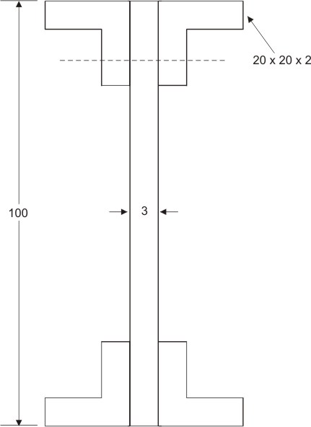

All dimensions in mm

Figure 1

13 (a) Derive the governing differential equation for an unidirectional anistropic plate
and reduce if to orthotropic plates and isotropic plates. (16)

( OR )

(b) List down the boundary conditions used for the analysis of laminated plate (both
simply supported and fixed edges) obtain the expression for the maximum
deflection of a simply supported orthotropic plate subjected to uniformly
distributed load of intensity q_{o}. (16)

14 (a) For the following laminate configuration compute the stiffness matrices. No of
layers 4, Each layer is 1mm thickness 0° / - 45 / 45° / 90°.
E₁ = 40 Gpa, E₂ = 8 Gpa G₁₂ > 4 Gpa. γ₁₂ = 0.25 (16)

( OR )

- A composite laminate has 3 layers with fibre orientation 0° / 90° / 0°. Top layer
an bottom layer thickness is 2mm (each and middle layer thickness is 3 mm.
Given N_{x} = 50 N/m, N_{y} = 200 N/m N_{xy} = 300 N/m M_{x} = 1000N, M_{y} = 1000
N & M_{xy} = 500N compute the strain and curvature. E₁ = 180 Gpa, E₂ = 15 Gpa,
G₁₂ = 7 Gpa, γ₁₂ = 0.28. (16)

15 (a) Describe any two methods for production of fibers (16)

( OR )

- Explain any two methods, one under open mould process and one under closed
mould process. (16)

